SUNDAY - THE MOST HOLY TRINITY
Saturday 11th June – St Barnabas, Apostle
12.30pm – Wedding (Convalidation) Gloria & Bernard Anani
4.00pm Confessions
5.00pm Mass – Fr Jim Teeling – 70th birthday

Sunday 12th June
9.30am Mass – Sr Nell R.I.P.
10.30am FHC Children’s Session in O’Sullivan Centre
NO TEA & COFFEE
11.00am Mass – People of the Parish
12.00 Noon – Baptism Scarlett Amelia Buckwell

Monday 13th June - St Anthony of Padua
NO MASS

Tuesday 14th June
12.00 Noon Requiem Mass – Eileen Middleton R.I.P.
1pm Garden of England Crematorium
6pm Mass – The Teeling Brothers 70th Birthday

Wednesday 15th June
10am Mass – People of Ukraine
7.30pm FHC Parents Session – O’Sullivan Centre

Thursday 16th June – St Richard of Chichester
10am Mass – Children of the Parish

Friday 17th June
10am NO MASS

SUNDAY- THE MOST HOLY BODY & BLOOD OF CHRIST
Saturday 18th June – The Blessed Virgin Mary
4.00pm Confessions
5.00pm Mass – People of the Parish
Sunday 19th June
9.00am Mass – John & Daisy Egan R.I.P.
NO TEA & COFFEE

NOTICES
MASS CHANGES
Please note that there will be no Mass MONDAY 13th June and FRIDAY 17th June this week Also on Tuesday 14th there is a Requiem Mass for the late Eileen Middleton at 12 Noon followed by committal at The Garden of England at 1pm. 6pm Mass will still take place Tuesday Evening

Next weekend there are just two Masses, 5pm Saturday 18th and 9am on Sunday 19th June.

The following week there will be NO Masses on Monday 20th and Tuesday 21st June.

TEA PARTY
Thank you to everybody that came along and enjoyed the Jubilee Tea Party and Quiz.
£647 was the total amount raised for the people of Ukraine. (See overleaf for further information regarding appeal for Ukraine).

BAPTISMAL FONT
As you may have noticed the Baptismal Font has undergone repairs and renovation and looks so much better for it! We are at present continuing the fundraising appeal for the cost of the repairs. Donations can also be made using the new digital collection plate in the Church entrance.
IMPORTANT NOTICE REGARDING CAR PARK
Can we gently remind all Parishioners that only the marked parking bays are to be used, if all bays are used up, please do not park just anywhere as this infringes emergency access and evacuation of the buildings if necessary.

Sunday 12th June 2022 – Mass Book page 81

MISSIO
Please can anyone in the possession of a Missio Red Box and who needs them to be emptied, please return the box to the Parish during Office hours or after Mass, please try to ensure your name is on the box when you return it. We have one box in the office returned by a collector some weeks ago, but it has no name on it. It has now been emptied so if this is yours, please come to collect it.

UKRAINE APPEAL
We are counting up all the money next week donated towards our Ukraine Appeal either through the purchasing of the Peace Candles or attending the Tea Party, so if anyone would still like to a purchase a Peace Candle to support this appeal, they are still available in the repository.

EASYFUNDRAISING – SUPPORT YOUR CHURCH!
Dear Parishioners, You can now help us to raise funds for the church every time you shop online with over 6,000 retailers, at no extra cost to yourselves via the Easyfundraising website and app. Please use the link below to sign up to Easyfundraising and choose to support the Sacred Heart of Jesus Sittingbourne.
https://www.easyfundraising.org.uk/invite/TERZUH/
Whenever you shop online, please visit the Easyfundraising website/app first and simply click through to your chosen retailer from there. Your retailer will then automatically donate a percentage of your purchase price to us, without costing you an extra penny! Please spread the word to your family and friends too. The more support we receive, the more money we can raise.

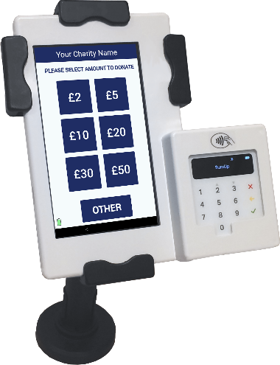
Now Accepting Contactless Donations
You will find our new DIGITAL COLLECTION PLATE, contactless terminal in the church. Just use your contactless debit/credit card or smart phone/device to make a donation. Simply choose the amount you wish to donate and hold your card onto the reader.
You can also opt-in for Gift Aid to increase your donation by 25%. If you are a UK taxpayer then donating with Gift Aid means that we can claim an extra 25p for every £1 received. Contactless donations are simple to administer, secure and convenient.
You only need to register your card for gift aid the first time, thereafter the machine automatically recognises your card and applies Gift Aid to your donation.

