SACRED HEART OF JESUS - NEWSLETTER
Parish Priest – Fr Graziano de Palma
Contact Details: Presbytery Phone – 01795 472619 – Office Phone – 01795 555708
Office Hours: Mon, Weds & Fri 9am -1pm sittingbourne@rcaos.org.uk

For your personal use, please take this newsletter away with you

Saturday THIRTEENTH SUNDAY OF ORDINARY TIME
26th June 4.30pm Confession
5pm People of the Parish
Sunday 27th June 9.30am Wellbeing of Ryan Lindsey
Sunday 27th June 11am Dennis & Alice O’Brien R.I.P
Monday 28th June NO MASS
Tuesday 29th June HOLY DAY- SAINTS PETER & PAUL, APOSTLES
10am Intentions of MaryAnn & Sue
6pm Wellbeing of Ryan Lindsey
Wednesday 30th June 10am Julia Anne Wheeles R.I.P
Thursday 1st July 10am Wellbeing of Janine & Christian
Friday 2nd July 10am The Kepa Family
Followed by Adoration & Chaplet of the Precious Blood
Saturday FOURTEENTH SUNDAY OF ORDINARY TIME
3rd July 4.30pm Confession
5pm People of the Parish
Sunday 4th July 9.30am Wellbeing of Ryan Lindsey
Sunday 4th July 11am Mass for the Catenians (President’s Sunday)

PLEASE NOTE HOLY DAY EVENING MASS WILL BE AT 6PM AS USUAL FOR A TUESDAY

Please remember to book your place at Mass by emailing the office at sittingbourne@rcaos.org.uk or phoning on Fridays 9am-3pm

Parish News
A BBQ together – official opening of the car park
Better late than never!

I would like to offer to you as a thank you for your
support during the pandemic a BBQ afternoon in July
This is not a fundraising event, but a thank you from me to you.
However, I would need your help……..

What do you think? Would you enjoy a BBQ?

Can you help with the BBQ? Do you have a large BBQ we could use?

Do you have any thoughts or suggestions? Please share them with me.
Please email the parish on sittingbourne@rcaos.org.uk

God Bless you all.

Fr Graziano

*** PLEASE SEE COVID UPDATE OVERLEAF ***

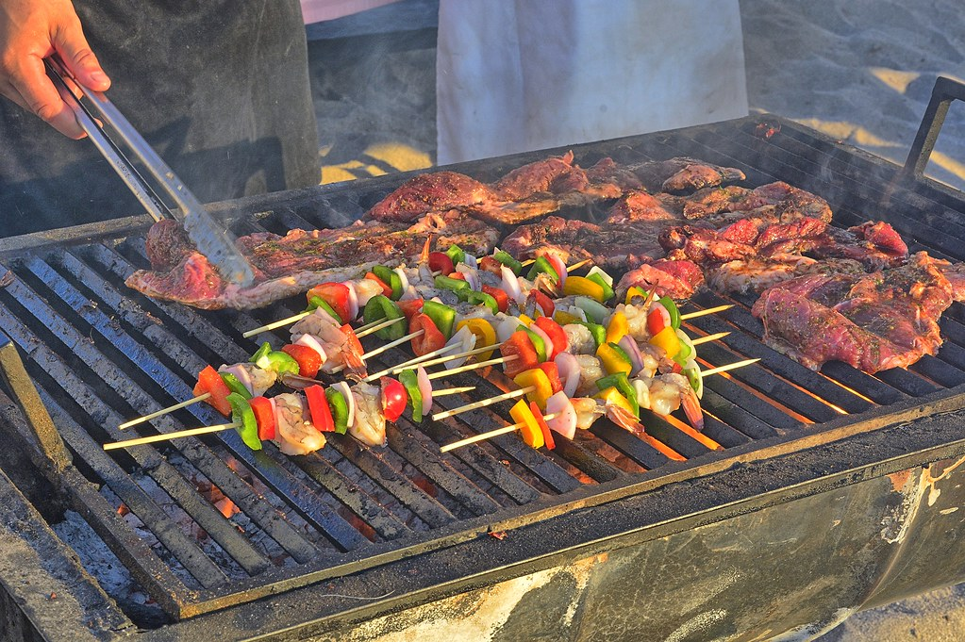

COVID-19 MEASURES STILL IN PLACE:
- Booking before attending Mass by email or calling the Parish Office (Monday, Wednesday, 9am - 1pm, Friday 9am - 3pm) providing full name, contact number and email/home address. This is to follow the NHS “Track and Trace” system imposed by the Government
- Body temperature check with the help of a steward
- Proper wearing of face coverings at all time
- Using of hand sanitizer entering and leaving the Church
- Using the “ONE WAY SYSTEM” entering the main front door and leaving by the side door of the church
- Congregational singing is not permitted
- Sign of the peace is omitted
- Children are not allowed to wander around the church for their own protection and other people’s safety
- Votive candles are available
- The congregation is invited to leave immediately after the Holy Mass allowing the stewards to sanitize the church

WHAT IS NEW?
- Following the Social Distancing rule of 1 metre or more, we can now accomodate 86 people. (The sitting areas have green signage). Please follow the guidance of the stewards.
- We can reintroduce bidding prayers
- The Offertory Procession is reintroduced with those involved sanitising their hands immediately before they touch the sacred vessel or other gifts
- The Holy Communion will continue to be under one kind and the Minister will continue to wear a face covering and it is permitted to announce “the Body of Christ” for each communicant. Communion is recommended to be distributed in the hands, but if people wish to receive on the tongue, then they should wait until the end of the communion line and receive then. Communion on the tongue exposes the ministers’ hands to their aerosol and inccreases the possibility of viral infections. He will have to sanitize his hands again immediately after.

13th Sunday in Ordinary Time – Year B

Entrance Antiphon.
All peoples, clap your hands. Cry to God with shouts of joy!
In the name of the Father, and of the Son, and of the Holy Spirit. Amen.

C. The Lord be with you
All. And with your Spirit

All: I confess to almighty God
And you my brothers and sisters,
That I have greatly sinned,
In my thoughts and in my words,
In what I have done and in what I have failed to do,
through my fault, through my fault,
through my most grievous fault;
therefore, I ask blessed Mary ever-virgin,
all the Angels and Saints,
and you my brothers and sisters,
to pray for me to the Lord our God.

C: Lord, have mercy. All: Lord, have mercy.
C: Christ have mercy. All: Christ have mercy.
C: Lord, have mercy. All: Lord, have mercy.

All: Glory to God in the highest
And on earth peace to people of goodwill.
We praise you,
We bless you,
We adore you; we glorify you; we give you thanks for your great glory,
Lord God, heavenly King,
O God, almighty Father.
Lord Jesus Christ, Only Begotten Son,
Lord God, Lamb of God, Son of the father,
You take away the sins of the world, have mercy on us;
You take away the sins of the world, receive our prayer;
You are seated at the right hand of the Father,
Have mercy on us.
For you alone are the Holy One,
You alone are the Lord,
You alone are the Most High
Jesus Christ,
With the Holy Spirit,
In the glory of God the Father.
Amen

C: Let us pray.

First Reading Ws. 1:13-15, 2:23-24
Death was not God’s doing,
he takes no pleasure in the extinction of the living.
To be – for this he created all;
the world’s created things have health in them,
in them no fatal poison can be found,
and Hades holds no power on earth;
for virtue is undying.
Yet God did make man imperishable,
he made him in the image of his own nature;
it was the devil’s envy that brought death into the world,
as those who are his partners will discover.
The word of the Lord.

Psalm: 29:2,4-6,11-13. R.v.2

Response: I will praise you, Lord, you have rescued me.
I will praise you, Lord, you have rescued me
and have not let my enemies rejoice over me.
O Lord, you have raised my soul from the dead,
restored me to life from those who sink into the grave. R#

Sing psalms to the Lord, you who love him,
give thanks to his holy name.
His anger lasts a moment; his favour all through life.
At night there are tears, but joy comes with dawn. R#

The Lord listened and had pity.
The Lord came to my help.
For me you have changed my mourning into dancing:
O Lord my God, I will thank you for ever. R#

Second Reading 2 Corinthians 8:7,9,13-15
You always have the most of everything – of faith, of eloquence, of understanding, of keenness for any cause, and the biggest share of our affection – so we expect you to put the most into this work of mercy too. Remember how generous the Lord Jesus was: he was rich, but he became poor for your sake, to make you rich out of his poverty. This does not mean that to give relief to others you ought to make things difficult for yourselves: it is a question of balancing what happens to be your surplus now against their present need, and one day they may have something to spare that will supply your own need. That is how we strike a balance: as scripture says: The man who gathered much had none too much, the man who gathered little did not go short.
The word of the Lord

Alleluia, alleluia!
Your words are spirit, Lord, and they are life:
you have the message of eternal life.
Alleluia!

Priest: The Lord be with you
All: And with your Spirit.

Priest: A reading from the Holy Gospel according to ….
All: Glory to you, O Lord.

Gospel Mark 4:35-41
[When Jesus had crossed in the boat to the other side, a large crowd gathered round him and he stayed by the lakeside. Then one of the synagogue officials came up, Jairus by name, and seeing him, fell at his feet and pleaded with him earnestly, saying, ‘My little daughter is desperately sick. Do come and lay your hands on her to make her better and save her life.’ Jesus went with him and a large crowd followed him; they were pressing all round him.] Now there was a woman who had suffered from a haemorrhage for twelve years; after long and painful treatment under various doctors, she spent all she had without being any the better for it, in fact, she was getting worse. She had heard about Jesus, and she came up behind him through the crowd and touched his cloak. ‘If I can touch even his clothes,’ she had told herself ‘I shall be well again.’ And the source of the bleeding dried up instantly, and she felt in herself that she was cured of her complaint. Immediately aware that power had gone out from him, Jesus turned round in the crowd and said, ‘Who touched my clothes?’ His disciples said to him, ‘You see how the crowd is pressing round you and yet you say, “Who touched me?”’ But he continued to look all round to see who had done it. Then the woman came forward, frightened and trembling because she knew what had happened to her, and she fell at his feet and told him the whole truth. ‘My daughter,’ he said ‘your faith has restored you to health; go in peace and be free from your complaint.’ [While he was still speaking some people arrived from the house of the synagogue official to say, ‘Your daughter is dead: why put the Master to any further trouble?’ But Jesus had overheard this remark of theirs and he said to the official, ‘Do not be afraid; only have faith.’ And he allowed no one to go with him except Peter and James and John the brother of James. So they came to the official’s house and Jesus noticed all the commotion, with people weeping and wailing unrestrainedly. He went in and said to them, ‘Why all this commotion and crying? The child is not dead, but asleep.’ But they laughed at him. So he turned them all out and, taking with him the child’s father and mother and his own companions, he went into the place where the child lay. And taking the child by the hand he said to her, ‘Talitha, kum!’ which means, ‘Little girl, I tell you to get up.’ The little girl got up at once and began to walk about, for she was twelve years old. At this they were overcome with astonishment, and he ordered them strictly not to let anyone know about it and told them to give her something to eat.]

Priest: The Gospel of the Lord
All: Praise to you, Lord Jesus Christ.

I believe in one God, the Father almighty, maker of heaven and earth, of all things visible and invisible. I believe in one Lord Jesus Christ, the Only Begotten Son of God, born of the Father before all ages. God from God, Light from Light, true God from true God, begotten, not made, consubstantial with the Father; through him all things were made. For us men and for our salvation he came down from heaven, (all bow) and by the Holy Spirit was incarnate of the Virgin Mary and became man. For our sake he was crucified under Pontius Pilate, he suffered death and was buried, and rose again on the third day in accordance with the Scriptures. He ascended into heaven and is seated at the right hand of the Father. He will come again in glory to judge the living and the dead and his kingdom will have no end. I believe in the Holy Spirit, the Lord, the giver of life, who proceeds from the Father and the Son, who with the Father and the Son is adored and glorified, who has spoken through the prophets. I believe in one, holy, catholic and apostolic Church I confess one Baptism for the forgiveness of sins and I look forward to the resurrection of the dead and the life of the world to come. Amen.

Liturgy of the Eucharist:
C: Pray, brethren….
All: May the Lord accept the sacrifice at your hands
for the praise and glory of his name
for our good and the good of all his holy Church.

C: The Lord be with you All: and with your Spirit
C: Lift up your hearts. All: We lift them up to the Lord.
C: Let us give thanks to the Lord our God. All: it is right and just.

All: Holy, Holy, Holy, Lord God of hosts
Heaven and earth are full of your glory
Hosanna in the highest.
Blessed is he who comes in the name of the Lord.
Hosanna in the highest.

Lord’s Prayer: Our Father…

C: ……. And the coming of our Saviour, Jesus Christ.

All: For the kingdom, the power and the glory are yours now and for ever.

All: Lamb of God, you take away the sins of the world, have mercy on us.
Lamb of God, you take away the sins of the world, have mercy on us.
Lamb of God, you take away the sins of the world, grant us peace.

C: Behold the Lamb of God…….

All: Lord, I am not worthy
that you should enter under my roof,
but only say the word
and my soul shall be healed.

(Before the Celebrant receives Communion, he will elevate the Host and then elevate the Chalice. Holy Communion then follows the Concluding Rites.)

C: THE BODY OF CHRIST. All: AMEN

C: THE BLOOD OF CHRIST. All: AMEN

Communion Antiphon: Ps.102:1
Bless the Lord, O my soul, and all within me, his holy name.

C: Let us Pray……….

C: The Lord be with you
All: And with your Spirit.

C: May Almighty God bless you,
The Father, and the Son, and the Holy Spirit.
All: Amen

Priest: Go in peace, glorifying the Lord by your life.
All: Thanks be to God.

