SACRED HEART OF JESUS - NEWSLETTER
Parish Priest – Fr Graziano de Palma
Contact Details: Presbytery Phone – 01795 472619 – Office Phone – 01795 555708
Office Hours: Mon, Weds & Fri 9am -1pm sittingbourne@rcaos.org.uk

For your personal use, please take this newsletter away with you
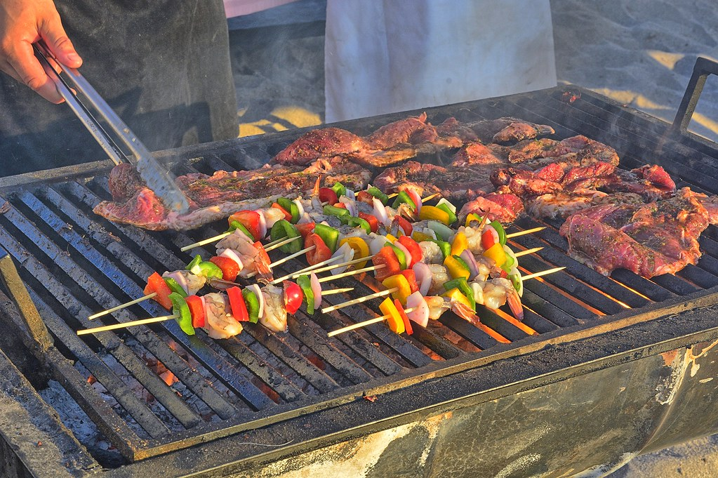
Parish News
A BBQ together – official opening of the car park, better late than never!

Thanks to 2 generous Parishioners who wish to remain anonymous, we now have our own parish BBQ. We are therefore arranging to hold the BBQ on Sunday 25th July at 2pm just prior to my holiday!

For catering purposes, we will need to know numbers attending so please email the office on sittingbourne@rcaos.org.uk to book in. There is no charge for the BBQ as this is my way of thanking everybody for their support to me and the Parish over the past 2 years. If however you would like to bring some salad, a pasta, rice dish or dessert, then all contributions will of course be very gratefully received.

God Bless you all. Fr Graziano
*** IMPORTANT NOTICE ABOUT AUGUST MASSES ***

Dear Parishioners, As you are all probably aware, due to the pandemic, restrictions on travel etc, I have not had a holiday allowing me to be able to visit my family in Italy, since the month before I arrived in the Parish back in September 2019. Therefore this year, I will be on leave for the entire month of August. It has been difficult to obtain supply cover as of course there are few “visiting supply Priests”.

During August there will be no weekday Mass and at the weekends starting from Sunday 1st August Mass will be at 9am only on Sundays, and 5pm on Saturdays.

********** SO THAT IS ONE MASS ONLY ON A SUNDAY AT 9AM ************

Saturday FOURTEENTH SUNDAY OF ORDINARY TIME
3rd July 4.30pm Confession
5pm People of the Parish
Sunday 4th July 9.30am Wellbeing of Ryan Lindsey
Sunday 4th July 11am Mass for the Catenians (President’s Sunday)
Monday 5th July NO MASS
Tuesday 6th July 6pm Wellbeing of Bogumila Stodulska (Birthday Celebrations)
Wednesday 7th July 10am Wellbeing of Ryan Lindsey
Thursday 8th July 10am Christine Streatfield (Birthday Celebrations)
Friday 9th July 10am Daniel Powel R.I.P.
Followed by Adoration & Chaplet of the Precious Blood
Saturday FIFTEENTH SUNDAY OF ORDINARY TIME
Sea Sunday - Apostleship of the Sea – Special Collection
10th July 4.30pm Confession
5pm Brian & Alice Attwater R.I.P.
Sunday 11th July 9.30am People of the Parish
Sunday 11th July 11am Catherine & James Devereux R.I.P.
12 noon Baptism – Ruby Holmes

Please remember to book your place at Mass by emailing the office at sittingbourne@rcaos.org.uk or phoning on Fridays 9am-3pm

COVID-19 MEASURES STILL IN PLACE:
- Booking before attending Mass by email or calling the Parish Office (Monday, Wednesday, 9am - 1pm, Friday 9am - 3pm) providing full name, contact number and email/home address. This is to follow the NHS “Track and Trace” system imposed by the Government
- Body temperature check with the help of a steward
- Proper wearing of face coverings at all time
- Using of hand sanitizer entering and leaving the Church
- Using the “ONE WAY SYSTEM” entering the main front door and leaving by the side door of the church
- Congregational singing is not permitted
- Sign of the peace is omitted
- Children are not allowed to wander around the church for their own protection and other people’s safety
- Votive candles are available
- The congregation is invited to leave immediately after the Holy Mass allowing the stewards to sanitize the church

WHAT IS NEW?
- Following the Social Distancing rule of 1 metre or more, we can now accomodate 86 people. (The sitting areas have green signage). Please follow the guidance of the stewards.
- We can reintroduce bidding prayers
- The Offertory Procession is reintroduced with those involved sanitising their hands immediately before they touch the sacred vessel or other gifts
- The Holy Communion will continue to be under one kind and the Minister will continue to wear a face covering and it is permitted to announce “the Body of Christ” for each communicant. Communion is recommended to be distributed in the hands, but if people wish to receive on the tongue, then they should wait until the end of the communion line and receive then. Communion on the tongue exposes the ministers’ hands to their aerosol and inccreases the possibility of viral infections. He will have to sanitize his hands again immediately after.

14th Sunday in Ordinary Time – Year B

Entrance Antiphon.
Your merciful love, O God, we have received in the midst of your temple. Your praise, O God, like your name, reaches the ends of the earth; your right hand is filled with saving justice.

In the name of the Father, and of the Son, and of the Holy Spirit. Amen.

C. The Lord be with you
All. And with your Spirit

All: I confess to almighty God
And you my brothers and sisters,
That I have greatly sinned,
In my thoughts and in my words,
In what I have done and in what I have failed to do,
through my fault, through my fault,
through my most grievous fault;
therefore, I ask blessed Mary ever-virgin,
all the Angels and Saints,
and you my brothers and sisters,
to pray for me to the Lord our God.

C: Lord, have mercy. All: Lord, have mercy.
C: Christ have mercy. All: Christ have mercy.
C: Lord, have mercy. All: Lord, have mercy.

All: Glory to God in the highest
And on earth peace to people of goodwill.
We praise you,
We bless you,
We adore you; we glorify you; we give you thanks for your great glory,
Lord God, heavenly King,
O God, almighty Father.
Lord Jesus Christ, Only Begotten Son,
Lord God, Lamb of God, Son of the father,
You take away the sins of the world, have mercy on us;
You take away the sins of the world, receive our prayer;
You are seated at the right hand of the Father,
Have mercy on us.
For you alone are the Holy One,
You alone are the Lord,
You alone are the Most High
Jesus Christ,
With the Holy Spirit,
In the glory of God the Father.
Amen

C: Let us pray.
First Reading Ezekiel 2:2-5
The spirit came into me and made me stand up, and I heard the Lord speaking to me. He said, ‘Son of man, I am sending you to the Israelites, to the rebels who have turned against me. Till now they and their ancestors have been in revolt against me. The sons are defiant and obstinate; I am sending you to them, to say, “The Lord says this.” Whether they listen or not, this set of rebels shall know there is a prophet among them.’
The word of the Lord.

Psalm: 122: R.v.2

Response: Our eyes are on the Lord till he shows us his mercy.
To you have I lifted up my eyes,
you who dwell in the heavens:
my eyes, like the eyes of slaves
on the hands of their lords. R#

Like the eyes of a servant
on the hands of her mistress,
so our eyes are on the Lord our God
till he shows us his mercy. R#

Have mercy on us, Lord, have mercy.
We are filled with contempt.
Indeed all to full is our soul
with the scorn of the rich,
with the proud man’s disdain. R#

Second Reading 2 Corinthians 12:7-10
In view of the extraordinary nature of these revelations, to stop me from getting too proud I was given a thorn in the flesh, an angel of Satan to beat me and stop me from getting too proud! About this thing, I have pleaded with the Lord three times for it to leave me, but he has said, ‘My grace is enough for you: my power is at its best in weakness.’ So I shall be very happy to make my weaknesses my special boast so that the power of Christ may stay over me, and that is why I am quite content with my weaknesses, and with insults, hardships, persecutions, and the agonies I go through for Christ’s sake. For it is when I am weak that I am strong.
The word of the Lord

Alleluia, alleluia!
The Word was made flesh and lived among us:
to all who did accept him he gave power to become children of God.
Alleluia!

Priest: The Lord be with you
All: And with your Spirit.

Priest: A reading from the Holy Gospel according to ….
All: Glory to you, O Lord.

Gospel Mark 6:1-6
Jesus went to his home town and his disciples accompanied him. With the coming of the sabbath he began teaching in the synagogue and most of them were astonished when they heard him. They said, ‘Where did the man get all this? What is this wisdom that has been granted him, and these miracles that are worked through him? This is the carpenter, surely, the son of Mary, the brother of James and Joset and Jude and Simon? His sisters, too, are they not here with us?’ And they would not accept him. And Jesus said to them, ‘A prophet is only despised in his own country, among his own relations and in his own house’; and he could work no miracle there, though he cured a few sick people by laying his hands on them. He was amazed at their lack of faith.
Priest: The Gospel of the Lord
All: Praise to you, Lord Jesus Christ.

I believe in one God, the Father almighty, maker of heaven and earth, of all things visible and invisible. I believe in one Lord Jesus Christ, the Only Begotten Son of God, born of the Father before all ages. God from God, Light from Light, true God from true God, begotten, not made, consubstantial with the Father; through him all things were made. For us men and for our salvation he came down from heaven, (all bow) and by the Holy Spirit was incarnate of the Virgin Mary and became man. For our sake he was crucified under Pontius Pilate, he suffered death and was buried, and rose again on the third day in accordance with the Scriptures. He ascended into heaven and is seated at the right hand of the Father. He will come again in glory to judge the living and the dead and his kingdom will have no end. I believe in the Holy Spirit, the Lord, the giver of life, who proceeds from the Father and the Son, who with the Father and the Son is adored and glorified, who has spoken through the prophets. I believe in one, holy, catholic and apostolic Church I confess one Baptism for the forgiveness of sins and I look forward to the resurrection of the dead and the life of the world to come. Amen.

Liturgy of the Eucharist:
C: Pray, brethren….
All: May the Lord accept the sacrifice at your hands
for the praise and glory of his name
for our good and the good of all his holy Church.

C: The Lord be with you All: and with your Spirit
C: Lift up your hearts. All: We lift them up to the Lord.
C: Let us give thanks to the Lord our God. All: it is right and just.

All: Holy, Holy, Holy, Lord God of hosts
Heaven and earth are full of your glory
Hosanna in the highest.
Blessed is he who comes in the name of the Lord.
Hosanna in the highest.

Lord’s Prayer: Our Father…

C: ……. And the coming of our Saviour, Jesus Christ.

All: For the kingdom, the power and the glory are yours now and for ever.

All: Lamb of God, you take away the sins of the world, have mercy on us.
Lamb of God, you take away the sins of the world, have mercy on us.
Lamb of God, you take away the sins of the world, grant us peace.

C: Behold the Lamb of God…….

All: Lord, I am not worthy
that you should enter under my roof,
but only say the word
and my soul shall be healed.

(Before the Celebrant receives Communion, he will elevate the Host and then elevate the Chalice. Holy Communion then follows the Concluding Rites.)

C: THE BODY OF CHRIST. All: AMEN

C: THE BLOOD OF CHRIST. All: AMEN

Communion Antiphon: Ps.33:9
Taste and see that the Lord is good;
blessed the man who seeks refuge in him.

C: Let us Pray……….

C: The Lord be with you
All: And with your Spirit.

C: May Almighty God bless you,
The Father, and the Son, and the Holy Spirit.
All: Amen

Priest: Go in peace, glorifying the Lord by your life.
All: Thanks be to God.

