LET US PRAY
We remember all who have recently died.

NOTICES
Mass on Thursday 19th May will be at 6pm
Please note there will be no Tea and Coffee next Sunday, 22nd May, as the Children’s FHC Session is taking place again.

Easyfundraising – Support your Church!
Dear Parishioners, You can now help us to raise funds for the church every time you shop online with over 6,000 retailers, at no extra cost to yourselves via the Easyfundraising website and app. Please use the link below to sign up to Easyfundraising and choose to support the Sacred Heart of Jesus Sittingbourne.
https://www.easyfundraising.org.uk/invite/TERZUH/
Whenever you shop online, please visit the Easyfundraising website/app first and simply click through to your chosen retailer from there. Your retailer will then automatically donate a percentage of your purchase price to us, without costing you an extra penny! Please spread the word to your family and friends too. The more support we receive, the more money we can raise.

Baptismal Font
We are continuing the fundraising appeal for the Baptismal Font, donations can also be made using the new digital collection plate in the Church entrance.

FIFTH SUNDAY OF EASTER
Saturday 14th May
4.00pm Confessions
5.00pm Mass – People of the Parish

Sunday 15th May
9.30am Mass - Children of the Parish
10.30am FHC Children’s Session in O’Sullivan Centre
NO TEA AND COFFEE THIS WEEK
11.00am Mass – Brian Kavanagh R.I.P.
12 Noon Baptism – Mia Thai

Monday 16th May – St Simon Stock, Priest
NO MASS

Tuesday 17th May
6pm Mass – Wellbeing of Adrian Tucker

Wednesday 18th May – St John I,Pope & Martyr
10am Mass – People of the Parish

Thursday 19th May – St Dunstan, Bishop
6pm Mass – the De Palma and Poli Families

Friday 20th May – St Bernardine of Sienna, Priest
10am Mass – Sick People of the Parish
Followed by Adoration & Chaplet of the Precious Blood

SIXTH SUNDAY OF EASTER
Saturday 21st May – St Christopher of Magallanes
4.00pm Confessions
5.00pm Mass – Private Intentions

Sunday 22nd May
9.30am Mass – Children of the Parish
10.30am FHC Children’s Session in O’Sullivan Centre
NO TEA AND COFFEE THIS WEEK
11.00am Mass – People of the Parish
12 Noon Baptism – Penny Shrubsole

Sunday 15th May 2022 – Mass Book page 271

MONTH OF MAY - DEDICATED TO OUR LADY
If you would like to lead the Rosary before Mass during May please speak to Fr Graziano.

HER MAJESTY THE QUEEN’S PLATINUM JUBILEE – AFTERNOON TEA PARTY FRIDAY 3RD JUNE 2022
We are holding an Afternoon Tea Party on the 3rd June which is a designated Special Bank Holiday this year, at 3pm to celebrate the Queen’s Platinum Jubilee. We intend to hold a raffle, do a quiz on the Royal Family, and have some tea and cakes. If you would like to help by making cakes for the Afternoon Tea please contact Sue at the parish office, please also contact the office to register your interest.

CANDLES FOR PEACE IN UKRAINE
Whilst we know many of you will have given individually, we thought it might be nice to join as a community and offer our prayers and support to the people of Ukraine. A parishioner has donated 48 peace candles along the lines of the memorial ones we had in November. If you would like to purchase a candle for £4 all the proceeds will go to help the people of Ukraine and our prayers for peace can light up the Church.

CONFIRMATION
The Confirmation catechists have now met up and it is planned to start catechesis for Confirmation for 2023 in November 2022. If your child is Year 8 or above and has received their First Holy Communion and would like to be confirmed please contact the office.

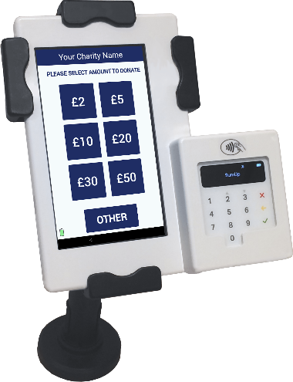
Now Accepting Contactless Donations
You will find our new DIGITAL COLLECTION PLATE, contactless terminal in the church. Just use your contactless debit/credit card or smart phone/ device to make a donation. Simply choose the amount you wish to donate and hold your card onto the reader.
You can also opt-in for Gift Aid to increase your donation by 25%. If you are a UK taxpayer then donating with Gift Aid means that we can claim an extra 25p for every £1 received. Contactless donations are simple to administer, secure and convenient.
You only need to register your card for gift aid the first time, thereafter the machine automatically recognises your card and applies Gift Aid to your donation.

