SACRED HEART OF JESUS - NEWSLETTER
Parish Priest – Fr Graziano de Palma
Contact Details: Presbytery Phone – 01795 472619 – Office Phone – 01795 555708
Office Hours: Mon, Weds & Fri 9am -1pm sittingbourne@rcaos.org.uk

For your personal use, please take this newsletter away with you
Saturday FIFTEENTH SUNDAY OF ORDINARY TIME
Sea Sunday - Apostleship of the Sea – Special Collection
10th July 4.30pm Confession
5pm Brian & Alice Attwater R.I.P.
Sunday 11th July 9.30am People of the Parish
Sunday 11th July 11am Catherine & James Devereux R.I.P.
12 noon Baptism – Ruby Holmes
Monday 12th July NO MASS
Tuesday 13th July 6pm Nicholas & MaryAnne Murphy R.I.P.
Wednesday 14th July 10am Henry Aguh Family Intentions
Thursday Saint Bonaventure, Bishop & Doctor of the Church
15th July 10am Wellbeing of John Branch
12 noon Requiem Mass -Ellen Teresa Teague R.I.P.
Friday Our Lady of Mount Carmel
16th July 10am Wellbeing of Lucy Marszalek & her Son
Followed by Adoration & Chaplet of the Precious Blood
Saturday SIXTEENTH SUNDAY OF ORDINARY TIME
17th July 4.30pm Confession
5pm Gerard O’Leary R.I.P.
Sunday 18th July 9.30am People of the Parish
Sunday 18th July 11am Mass for the recently bereaved
2.00pm Blessing of the Graves
Please remember to book your place at Mass by emailing the office at sittingbourne@rcaos.org.uk or phoning on Fridays 9am-3pm

Parish News
A BBQ together – official opening of the car park, better late than never!

Thanks to 2 generous Parishioners who wish to remain anonymous, we now have our own parish BBQ. We are therefore arranging to hold the BBQ on Sunday 25th July at 2pm just prior to my holiday!

For catering purposes, we will need to know numbers attending so please email the office on sittingbourne@rcaos.org.uk to book in. There is no charge for the BBQ as this is my way of thanking everybody for their support to me and the Parish over the past 2 years. If however you would like to bring some salad, a pasta, rice dish or dessert, then all contributions will of course be very gratefully received.

God Bless you all. Fr Graziano
*** IMPORTANT NOTICE ABOUT AUGUST MASSES ***

Dear Parishioners, As you are all probably aware, due to the pandemic, restrictions on travel etc, I have not had a holiday allowing me to be able to visit my family in Italy, since the month before I arrived in the Parish back in September 2019. Therefore this year, I will be on leave for the entire month of August. It has been difficult to obtain supply cover as of course there are few “visiting supply Priests”.

During August there will be no weekday Mass and at the weekends starting from Sunday 1st August Mass will be at 9am only on Sundays, and 5pm on Saturdays.

********** SO THAT IS ONE MASS ONLY ON A SUNDAY AT 9AM ************

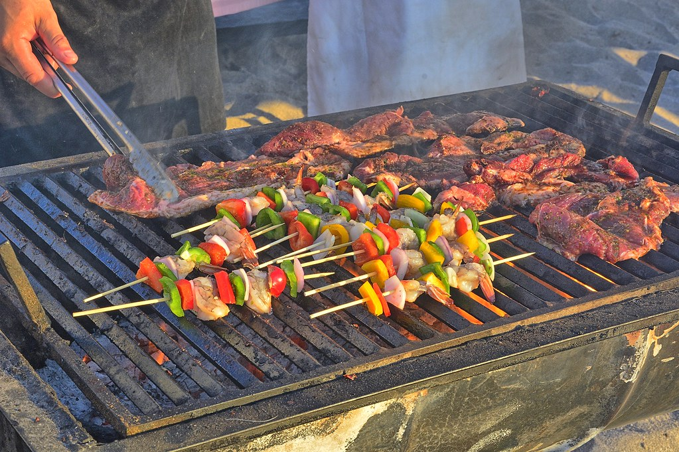

COVID-19 MEASURES STILL IN PLACE:
- Booking before attending Mass by email or calling the Parish Office (Monday, Wednesday, 9am - 1pm, Friday 9am - 3pm) providing full name, contact number and email/home address. This is to follow the NHS “Track and Trace” system imposed by the Government
- Body temperature check with the help of a steward
- Proper wearing of face coverings at all time
- Using of hand sanitizer entering and leaving the Church
- Using the “ONE WAY SYSTEM” entering the main front door and leaving by the side door of the church
- Congregational singing is not permitted
- Sign of the peace is omitted
- Children are not allowed to wander around the church for their own protection and other people’s safety
- Votive candles are available
- The congregation is invited to leave immediately after the Holy Mass allowing the stewards to sanitize the church

WHAT IS NEW?
- Following the Social Distancing rule of 1 metre or more, we can now accomodate 86 people. (The sitting areas have green signage). Please follow the guidance of the stewards.
- We can reintroduce bidding prayers
- The Offertory Procession is reintroduced with those involved sanitising their hands immediately before they touch the sacred vessel or other gifts
- The Holy Communion will continue to be under one kind and the Minister will continue to wear a face covering and it is permitted to announce “the Body of Christ” for each communicant. Communion is recommended to be distributed in the hands, but if people wish to receive on the tongue, then they should wait until the end of the communion line and receive then. Communion on the tongue exposes the ministers’ hands to their aerosol and inccreases the possibility of viral infections. He will have to sanitize his hands again immediately after.

15th Sunday in Ordinary Time – Year B

Entrance Antiphon.
As for me, in justice I shall behold your face; I shall be filled with the vision of your glory.

In the name of the Father, and of the Son, and of the Holy Spirit. Amen.

C. The Lord be with you
All. And with your Spirit

All: I confess to almighty God
And you my brothers and sisters,
That I have greatly sinned,
In my thoughts and in my words,
In what I have done and in what I have failed to do,
through my fault, through my fault,
through my most grievous fault;
therefore, I ask blessed Mary ever-virgin,
all the Angels and Saints,
and you my brothers and sisters,
to pray for me to the Lord our God.

C: Lord, have mercy. All: Lord, have mercy.
C: Christ have mercy. All: Christ have mercy.
C: Lord, have mercy. All: Lord, have mercy.

All: Glory to God in the highest
And on earth peace to people of goodwill.
We praise you,
We bless you,
We adore you; we glorify you; we give you thanks for your great glory,
Lord God, heavenly King,
O God, almighty Father.
Lord Jesus Christ, Only Begotten Son,
Lord God, Lamb of God, Son of the father,
You take away the sins of the world, have mercy on us;
You take away the sins of the world, receive our prayer;
You are seated at the right hand of the Father,
Have mercy on us.
For you alone are the Holy One,
You alone are the Lord,
You alone are the Most High
Jesus Christ,
With the Holy Spirit,
In the glory of God the Father.
Amen

C: Let us pray.

First Reading Amos 7:12-15
Amaziah, the priest of Bethel, said to Amos, ‘Go away, seer;’ get back to the land of Judah; earn your bread there, do your prophesying there. We want no more prophesying in Bethel; this is the royal sanctuary, the national temple.’ ‘I was no prophet, neither did I belong to any of the brotherhoods of prophets,’ Amos replied to Amaziah ‘I was a shepherd, and looked after sycamores: but it was the Lord who took me from herding the flock, and the Lord who said, “Go, prophesy to my people Israel.”’ The word of the Lord.

Psalm: 84:9-14. R.V.8

Response: Let us see, O Lord, your mercy and give us your saving help.
I will hear what the Lord God has to say,
a voice speaks of peace,
peace for his people.
His help is near for those who fear him
and his glory will dwell in our land. R#

Mercy and faithfulness have met;
justice and peace have embraced.
Faithfulness shall spring from the earth
and justice look down from the heaven. R#

The Lord will make us prosper
and our earth shall yield its fruit.
Justice shall march before him
and peace shall follow his steps. R#

Second Reading Ephesians 1:3-14
Blessed be God the Father of our Lord Jesus Christ,
who has blessed us with all the spiritual blessings of heaven in Christ.
Before the world was made, he chose us, chose us in Christ,
to be holy and spotless, and to live through love in his presence,
determining that we should become his adopted sons, through Jesus Christ
for his own kind purposes,
to make us praise the glory of his grace,
his free gift to us in the Beloved,
in whom, through his blood, we gain our freedom, the forgiveness of our sins.
Such is the richness of the grace
which he has showered on us
in all wisdom and insight.
He has let us know the mystery of his purpose,
the hidden plan he so kindly made in Christ from the beginning
to act upon when the times had run their course to the end:
that he would bring everything together under Christ, as head,
everything in the heavens and everything on earth.
And it is in him that we were claimed as God’s own,
chosen from the beginning,
under the predetermined plan of the one who guides all things
as he decides by his own will;
chosen to be,
for his greater glory,
the people who would put their hopes in Christ before he came.
Now you too, in him,
have heard the message of the truth and the good news of your salvation,
and have believed it;
and you too have been stamped with the seal of the Holy Spirit of the Promise,
the pledge of our inheritance
which brings freedom for those whom God has taken for his own, to make his glory praised. The word of the Lord

Alleluia, alleluia!
Your words are spirit, Lord, and they are life;
you have the message of eternal life.
Alleluia!

Priest: The Lord be with you
All: And with your Spirit.

Priest: A reading from the Holy Gospel according to ….
All: Glory to you, O Lord.

Gospel Mark 6:7-13
Jesus made a tour round the villages, teaching. Then he summoned the Twelve and began to send them out in pairs giving them authority over the unclean spirits. And he instructed them to take nothing for the journey except a staff – no bread, no haversack, no coppers for their purses. They were to wear sandals but, he added, ‘Do not take a spare tunic.’ And he said to them, ‘If you enter a house anywhere, stay there until you leave the district. And if any place does not welcome you and people refuse to listen to you, as you walk away shake off the dust from under your feet as a sign to them.’ So they set off to preach repentance; and they cast out many devils and anointed many sick people with oil and cured them.

Priest: The Gospel of the Lord
All: Praise to you, Lord Jesus Christ.

I believe in one God, the Father almighty, maker of heaven and earth, of all things visible and invisible. I believe in one Lord Jesus Christ, the Only Begotten Son of God, born of the Father before all ages. God from God, Light from Light, true God from true God, begotten, not made, consubstantial with the Father; through him all things were made. For us men and for our salvation he came down from heaven, (all bow) and by the Holy Spirit was incarnate of the Virgin Mary and became man. For our sake he was crucified under Pontius Pilate, he suffered death and was buried, and rose again on the third day in accordance with the Scriptures. He ascended into heaven and is seated at the right hand of the Father. He will come again in glory to judge the living and the dead and his kingdom will have no end. I believe in the Holy Spirit, the Lord, the giver of life, who proceeds from the Father and the Son, who with the Father and the Son is adored and glorified, who has spoken through the prophets. I believe in one, holy, catholic and apostolic Church I confess one Baptism for the forgiveness of sins and I look forward to the resurrection of the dead and the life of the world to come. Amen.

Liturgy of the Eucharist:

C: Pray, brethren….
All: May the Lord accept the sacrifice at your hands
for the praise and glory of his name
for our good and the good of all his holy Church.

C: The Lord be with you All: and with your Spirit
C: Lift up your hearts. All: We lift them up to the Lord.
C: Let us give thanks to the Lord our God. All: it is right and just.
All: Holy, Holy, Holy, Lord God of hosts
Heaven and earth are full of your glory
Hosanna in the highest.
Blessed is he who comes in the name of the Lord.
Hosanna in the highest.

Lord’s Prayer: Our Father…

C: ……. And the coming of our Saviour, Jesus Christ.

All: For the kingdom, the power and the glory are yours now and for ever.

All: Lamb of God, you take away the sins of the world, have mercy on us.
Lamb of God, you take away the sins of the world, have mercy on us.
Lamb of God, you take away the sins of the world, grant us peace.

C: Behold the Lamb of God…….

All: Lord, I am not worthy
that you should enter under my roof,
but only say the word
and my soul shall be healed.

(Before the Celebrant receives Communion, he will elevate the Host and then elevate the Chalice. Holy Communion then follows the Concluding Rites.)

C: THE BODY OF CHRIST. All: AMEN

C: THE BLOOD OF CHRIST. All: AMEN

Communion Antiphon: Ps.83:4-5
The sparrow finds a home, and the swallow a nest for her young;
by your altars, O Lord of hosts, my King and my God.
Blessed are they who dwell in your house, for ever singing your praise.

C: Let us Pray……….

C: The Lord be with you
All: And with your Spirit.

C: May Almighty God bless you,
The Father, and the Son, and the Holy Spirit.
All: Amen

Priest: Go in peace, glorifying the Lord by your life.
All: Thanks be to God.

