SUNDAY- THE MOST HOLY BODY & BLOOD OF CHRIST
Saturday 18th June – The Blessed Virgin Mary
4.00pm Confessions
5.00pm Mass – People of the Parish

Sunday 19th June
9.00am Mass – John & Daisy Egan R.I.P.
NO TEA & COFFEE

Monday 20th June – St Alban, Martyr
NO MASS

Tuesday 21stJune – St Aloysius
NO MASS

Wednesday 22nd June – Sts John Fisher and Thomas More, Martyrs
10am Mass – Pauline de Michele R.I.P.
7.30pm FHC Parents Session – O’Sullivan Centre

Thursday 23rd June – The Nativity of St John the Baptist
10am Mass – John Sutton R.I.P.

Friday 24th June – The Most Sacred Heart of Jesus
11.30am Requiem Mass – Sr Nell R.I.P.

SUNDAY- THIRTEENTH SUNDAY
Saturday 25th June
4.00pm Confessions
5.00pm Mass – People of the Parish

Sunday 26th June
9.30am Mass – Children of the Parish
10.30am Tea & Coffee in The O’Sullivan Centre
11.00am Mass – Sick & Housebound of the Parish

NOTICES
MASS CHANGES
Please note that there will be no Mass Monday 20th and Tuesday 21st June.
On Friday there will be no 10am, but a Requiem Mass for Sr Nell at 11.30am

TEA PARTY
Thank you to everybody that came along and enjoyed the Jubilee Tea Party and Quiz.
£647 was the total amount raised for the people of Ukraine.

BAPTISMAL FONT
As you may have noticed the Baptismal Font has undergone repairs and renovation and looks so much better for it! We are at present continuing the fundraising appeal for the cost of the repairs. Donations can also be made using the new digital collection plate in the Church entrance.

MISSIO
Please can anyone in the possession of a Missio Red Box and who needs them to be emptied, please return the box to the Parish during Office hours or after Mass, please try to ensure your name is on the box when you return it. We have one box in the office returned by a collector some weeks ago, but it has no name on it. It has now been emptied so if this is yours, please come to collect it.

LUCKY NUMBERS
The June results are as follows:
1st - 89 , 2nd - 9 , 3rd – 1 , 4th - 150

Sunday 19th June 2022 – Mass Book page 83

Dear Parishioners,
As I announced last week, I will be leaving Sittingbourne at the end of July, taking a break in August before starting my new appointment in Tunbridge Wells in September. Change is not easy for any of us but is an inevitable part of life, and for me as Priest is an exercise of obedience to our Mother Church.
I know I leave behind me a strong and vibrant community that I have been very happy to serve as your Parish Priest. Parishioners are back, gathered around the same altar to celebrate Jesus. Families are feeling welcomed with their children preparing for their sacramental initiation. The sick and housebound have been looked after to the best of my ability given the constraints of the pandemic.
Even with the pandemic we have also been able to make many improvements on the church premises and started new initiatives. Starting with the car park and finishing with the restoration of the baptism font. Some of these projects will continue when I have gone. I will have to return to see the work on the “toilet block” complete. I thank you all for your financial support enabling these projects to be completed.
I would like to invite you to join me in sharing a BBQ on 24 July at 2pm. This is not a farewell lunch it’s a celebration of our three years together. More details to follow nearer the time.
Please continue to pray for me as I will pray for the community of the Sacred Heart of Jesus. God Bless you all.
Fr Graziano de Palma

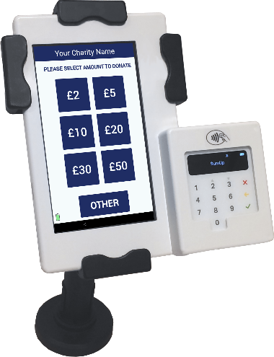
Now Accepting Contactless Donations
You will find our new DIGITAL COLLECTION PLATE, contactless terminal in the church. Just use your contactless debit/credit card or smart phone/device to make a donation. Simply choose the amount you wish to donate and hold your card onto the reader.
You can also opt-in for Gift Aid to increase your donation by 25%. If you are a UK taxpayer then donating with Gift Aid means that we can claim an extra 25p for every £1 received. Contactless donations are simple to administer, secure and convenient.
You only need to register your card for gift aid the first time, thereafter the machine automatically recognises your card and applies Gift Aid to your donation.

