SEVENTH SUNDAY OF EASTER
Saturday 28th May
4.00pm Confessions
5.00pm Mass – People of the Parish

Sunday 29th May
9.30am Mass – Fr Michael Branch 25th Anniversary of Ordination
10.30am Tea & Coffee in the O’Sullivan Centre
11.00am Mass – Aneta’s Intentions
12 Noon Baptism – Nevaeh Selasi Pirogue

Monday 30th May
NO MASS

Tuesday 31st May – Visitation of
the Blessed Virgin Mary
6pm Mass – Sr Nell R.I.P.

Wednesday 1st June – St Justin, Martyr
10am Mass – Private Intentions

Thurs 2nd June – Sts Marcellinus & Peter, Martyrs
10am Mass – Private Intentions

Friday 3rd June – St Charles Lwanga & Companions
10am Mass – Sick & Housebound of the Parish
Followed by Adoration & Chaplet of the Precious Blood
3pm Queen’s Jubilee Afternoon Tea in Carmel Hall

PENTECOST SUNDAY
Saturday 4th June
4.00pm Confessions
5.00pm Mass – HM Queen Elizabeth II

Sunday 5th June – HM Queen Elizabeth II Platinum Jubilee
9.30am Mass – Sr Nell R.I.P.
10.30am Tea & Coffee in the O’Sullivan Centre
11.00am Mass – People of the Parish

NOTICES
HER MAJESTY THE QUEEN’S PLATINUM JUBILEE – AFTERNOON TEA PARTY FRIDAY 3RD JUNE 2022
We are holding an Afternoon Tea Party on Friday the 3rd June which is a designated Special Bank Holiday this year, at 3pm to celebrate the Queen’s Platinum Jubilee. We intend to hold a raffle, do a quiz on the Royal Family, and have some tea and cakes. If you would like to help by making cakes for the Afternoon Tea please contact Sue at the parish office, please also contact the office to register your interest by Wednesday 1st June .

CONFIRMATION
The Confirmation catechists have now met up and it is planned to start catechesis for Confirmation for 2023 in November 2022. If your child is Year 8 or above and has received their First Holy Communion and would like to be confirmed please contact the office.

BAPTISMAL FONT
We are continuing the fundraising appeal for the Baptismal Font, donations can also be made using the new digital collection plate in the Church entrance.

IMPORTANT NOTICE REGARDING CAR PARK
Can we gently remind all Parishioners that only the marked parking bays are to be used, if all bays are used up, please do not park just anywhere as this infringes emergency access and evacuation of the buildings if necessary.

LUCKY NUMBERS
May Results;1st - 55, 2nd - 120, 3rd – 97, 4th – 1
Apr Results;1st- 122, 2nd – 95, 3rd – 45, 4th – 59
Mar Results:1st – 99, 2nd 91, 3rd -1, 4th -70
Feb Results: 1st - 103, 2nd – 144, 3rd -70 4th - 121
Jan Results: 1st - 41, 2nd - 11, 3rd - 22 and 4th - 84

Sunday 29th May 2022 – Mass Book page 281

Spring Plenary 2022 Resolution – Extract from “An invitation from the Bishops of England and Wales”
Attending Mass on Sundays and Holy Days is the greatest of all privileges, sometimes referred to as “the Sunday Obligation.”
Since the beginning of the Covid pandemic, until the present time, we have shared with you our judgment that the situation of the last two years has meant that the Sunday Obligation has been impeded and has needed to be fulfilled in other ways. We thank God that this situation has now changed. The pressing challenges of the pandemic have lessened significantly. Most people have resumed the wide range of normal activities, no longer restricted by the previous Covid measures. We therefore believe that the reasons which have prevented Catholics from attending Mass on Sundays and Holy Days of Obligation no longer apply.
We understand there will still be some members of our congregations who, for reasons of health, do not feel safe enough to return to Mass. It has always been the understanding of the Church that when the freedom of any Catholic to attend Mass in person is impeded for a serious reason, because of situations such as ill health, care for the sick or legitimate fear, this is not a breach of the Sunday Obligation.
In the Holy Sacrifice of the Mass, the Lord’s Supper, the Lord Jesus entrusted to us the precious gift of Himself. With humility, we glory in being a Eucharistic people for whom attendance at Mass is essential. Looking forward to the forthcoming feast of Pentecost, we now invite all Catholics who have not yet done so to return to attending Mass in person.
Approved by the Plenary Assembly of the Bishops’ Conference
Friday 6 May 2022

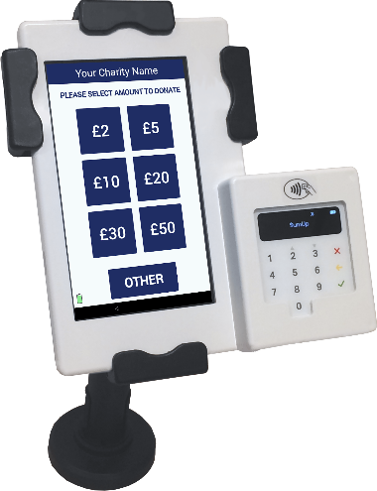
Now Accepting Contactless Donations
You will find our new DIGITAL COLLECTION PLATE, contactless terminal in the church. Just use your contactless debit/credit card or smart phone/device to make a donation. Simply choose the amount you wish to donate and hold your card onto the reader.
You can also opt-in for Gift Aid to increase your donation by 25%. If you are a UK taxpayer then donating with Gift Aid means that we can claim an extra 25p for every £1 received. Contactless donations are simple to administer, secure and convenient.
You only need to register your card for gift aid the first time, thereafter the machine automatically recognises your card and applies Gift Aid to your donation.

