PENTECOST SUNDAY
Saturday 4th June
4.00pm Confessions
5.00pm Mass – HM Queen Elizabeth II

Sunday 5th June – HM Queen Elizabeth II Platinum Jubilee
9.30am Mass – Sr Nell R.I.P.
10.30am Tea & Coffee in the O’Sullivan Centre
11.00am Mass – People of the Parish

Monday 6th June – Mary, Mother of the Church
NO MASS
Tuesday 7th June
6pm Mass – Sick of the parish

Wednesday 8th June
10am Mass – Children of the parish
7.30pm FHC Parents Session – O’Sullivan Centre

Thursday 9th June – Our Lord Jesus Christ
Eternal High Priest
10am Mass – Private Intentions
Friday 10th June
10am Mass – Archbishop John Wilson (3rd Anniv)
Followed by Adoration & Chaplet of the Precious Blood

SUNDAY - THE MOST HOLY TRINITY
Saturday 11th June – St Barnabas, Apostle
12.00 Noon – Wedding (Convalidation) Gloria & Bernard Anani
4.00pm Confessions
5.00pm Mass – Fr Jim Teeling – 70th birthday

Sunday 12th June
9.30am Mass – Sr Nell R.I.P.
10.30am FHC Children’s Session in O’Sullivan Centre
NO TEA & COFFEE
11.00am Mass – People of the Parish
12.00 Noon – Baptism Scarlett Amelia Buckwell

NOTICES
Prayer for the Queen
Following the Prayer after Communion:
P. O Lord, save Elizabeth, our Queen.
R. And hear us on the day we call upon you.
P. O Lord, hear my prayer.
R. And let my cry come before you.
P. The Lord be with you.
R. And with your spirit.
Almighty God, we pray,
that your servant Elizabeth, our Queen,
who, by your providence has received the governance of this realm,
may continue to grow in every virtue,
that, imbued with your heavenly grace,
she may be preserved from all that is harmful and evil
and, being blessed with your favour
may, with the royal family,
come at last into your presence,
through Christ who is the way, the truth and the life
and who lives and reigns with you
in the unity of the Holy Spirit,
one God, for ever and ever.
Amen

BAPTISMAL FONT
We are continuing the fundraising appeal for the Baptismal Font, donations can also be made using the new digital collection plate in the Church entrance.

IMPORTANT NOTICE REGARDING CAR PARK
Can we gently remind all Parishioners that only the marked parking bays are to be used, if all bays are used up, please do not park just anywhere as this infringes emergency access and evacuation of the buildings if necessary.

Sunday 5th June 2022 – Mass Book page 294

Spring Plenary 2022 Resolution – Extract from “An invitation from the Bishops of England and Wales”
Attending Mass on Sundays and Holy Days is the greatest of all privileges, sometimes referred to as “the Sunday Obligation.”
Since the beginning of the Covid pandemic, until the present time, we have shared with you our judgment that the situation of the last two years has meant that the Sunday Obligation has been impeded and has needed to be fulfilled in other ways. We thank God that this situation has now changed. The pressing challenges of the pandemic have lessened significantly. Most people have resumed the wide range of normal activities, no longer restricted by the previous Covid measures. We therefore believe that the reasons which have prevented Catholics from attending Mass on Sundays and Holy Days of Obligation no longer apply.
We understand there will still be some members of our congregations who, for reasons of health, do not feel safe enough to return to Mass. It has always been the understanding of the Church that when the freedom of any Catholic to attend Mass in person is impeded for a serious reason, because of situations such as ill health, care for the sick or legitimate fear, this is not a breach of the Sunday Obligation.
In the Holy Sacrifice of the Mass, the Lord’s Supper, the Lord Jesus entrusted to us the precious gift of Himself. With humility, we glory in being a Eucharistic people for whom attendance at Mass is essential. Looking forward to the forthcoming feast of Pentecost, we now invite all Catholics who have not yet done so to return to attending Mass in person.
Approved by the Plenary Assembly of the Bishops’ Conference
Friday 6 May 2022

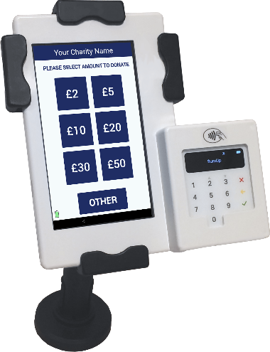
Now Accepting Contactless Donations
You will find our new DIGITAL COLLECTION PLATE, contactless terminal in the church. Just use your contactless debit/credit card or smart phone/device to make a donation. Simply choose the amount you wish to donate and hold your card onto the reader.
You can also opt-in for Gift Aid to increase your donation by 25%. If you are a UK taxpayer then donating with Gift Aid means that we can claim an extra 25p for every £1 received. Contactless donations are simple to administer, secure and convenient.
You only need to register your card for gift aid the first time, thereafter the machine automatically recognises your card and applies Gift Aid to your donation.

