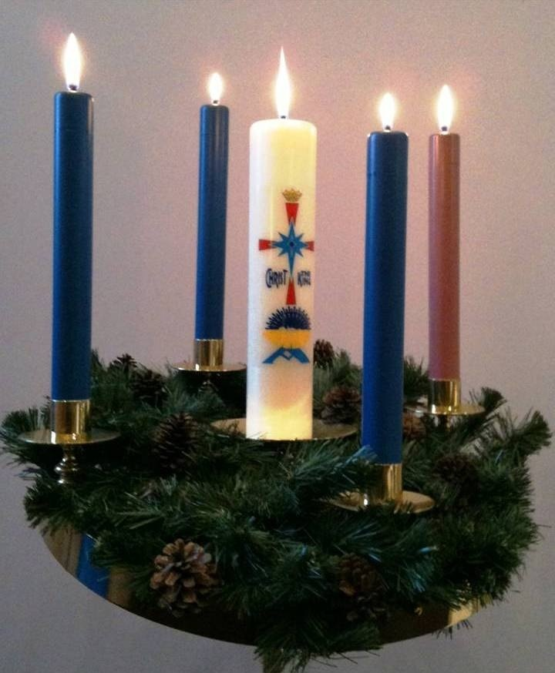
CELEBRATING ADVENT AT HOME
Advent is the season leading up to Christmas. It begins four Sundays before December 25 and is our time of preparation for our yearly celebration of the birth of Jesus into our world. Lighting the candles on an Advent wreath in the weeks leading up to Christmas is a great way to help us remember that we are preparing to celebrate the birth of Christ. In church, every week another candle is lit as we journey towards Christmas. As we do in church, it is customary to have an Advent wreath in our homes and to light a candle for each week of Advent. Prayers typically accompany the lighting and this can be done at every evening meal or on the first evening meal of the week.
This is also the time to be creative. For the candle lighting, if you don't often gather as a family because dinner time is hectic with activities, create a new tradition and make it a before-bedtime ritual to light a candle and say a few prayers reflecting on the day that has ended. Or if morning works better, start the day with Advent prayers holding in our hearts our hopes for the day ahead and lighting the Advent candle over breakfast. If you are by yourself, you can create your own ritual, knowing that you are joining with Christians around the world in this sacred season. Instead of sharing out loud, journal your responses to the questions asked during the sharing time.
The use of the wreath and candles during Advent are a longstanding Catholic tradition that was originally adopted by Christians in the Middle Ages as part of their spiritual preparation for Christmas.
The wreath and candles are full of symbolism tied to the Christmas season. The wreath itself, which is made of various evergreens, signifies continuous life. The circle of the wreath, which has no beginning or end, symbolizes the eternity of God, the immortality of the soul, and the everlasting life we find in Christ.
The candles also have their own special significance. The four candles represent the four weeks of Advent, and one candle is lit each Sunday. Three of the candles are purple because the colour violet is a liturgical colour that signifies a time of prayer, penance, and sacrifice.
The first candle, which is purple, symbolizes hope. It is sometimes called the “Prophecy Candle” in remembrance of the prophets, especially Isaiah, who foretold the birth of Christ. It represents the expectation felt in anticipation of the coming Messiah.
The second candle, also purple, represents faith. It is called the “Bethlehem Candle” as a reminder of Mary and Joseph’s journey to Bethlehem.
The third candle is pink and symbolizes joy. It is called the “Shepherd’s Candle,” and is pink because rose is a liturgical colour for joy. The third Sunday of Advent is Gaudete Sunday and is meant to remind us of the joy that the world experienced at the birth of Jesus, as well as the joy that the faithful have reached the midpoint of Advent.
On the fourth week of Advent, we light the final forth purple candle to mark the final week of prayer and penance as we wait for the birth of our Saviour. This final candle, the “Angel’s Candle,” symbolizes peace. It reminds us of the message of the angels: “Peace on Earth, Good Will Toward Men.”
Though the Advent wreath does not include a white candle, this is a tradition that has become popular in modern day adaptations. The white candle is placed in the middle of the wreath and lit on Christmas Eve. This candle is called the “Christ Candle” and represents the life of Christ. The colour white is for purity—because Christ is our sinless, pure Saviour.
Notes: Traditionally, the youngest child lights the candle the first week, the oldest child the second week, one parent the third week and the other parent the fourth week. However, these roles can be chosen to make sure everyone is included and there is family peace.

BLESSING OF THE ADVENT WREATH
When the blessing of the Advent Wreath is celebrated in the home, it is appropriate that it be blessed by a parent or another member of the family.
Leader: Lord our God, we praise you for your Son, Jesus Christ: he is Emmanuel, the hope of the peoples, he is the wisdom that teaches and guides us, he is the Saviour of every nation. Lord God, let your blessing come upon us as we light the candles of this wreath. May the wreath and its light be a sign of Christ’s promise to bring us salvation. May he come quickly and not delay. We ask this through Christ our Lord. Amen.

PRAYERS TO USE WITH YOUR ADVENT WREATH
First Sunday of Advent - A Week of Hope – 29 Now-5 Dec
Reader 1: According to tradition, each candle has a special meaning. The first one, usually purple, is called the candle of hope. People in the Old Testament knew that God had promised to send a Saviour. And we’re filled with hope because we know that Jesus came to Earth on the first Christmas so he could tell people about God and die for our sins. As we get ready to light the first candle on your Advent wreath, let us listen to a reading from Romans.
Reader 2: I pray that God, the source of hope, will fill you completely with joy and peace because you trust in him. Then you will overflow with confident hope through the power of the Holy Spirit. Romans 15:13.
Sharing: Share some ways that you’re filled with hope because you know Jesus or how Jesus makes a difference in your lives.
After sharing, the first purple or a blue candle is lit and all say,
All: One candle, burning bright, Chasing away the darkness from light. One candle, glowing light, The blessing of God, giving new sight.
Reader 2: Let us pray. Dear God, we pray for the hope that is in Christ to come into our lives in a new way. May we become hope that is alive in our world. Amen.

Second Sunday of Advent – A Week of Preparation - Dec 7– 12
Reader 1: The second candle on an Advent wreath, usually purple, represents preparation. Listen to a reading from Mark.
Reader 2: He is a voice shouting in the wilderness, ‘Prepare the way for the Lord’s coming! Clear the road for him!’ This messenger was John the Baptist. He was in the wilderness and preached that people should be baptized to show that they had repented of their sins and turned to God to be forgiven. Mark 1:3-4
Reader 1: John the Baptist, Jesus’ cousin, spread the word that Jesus was on his way. Part of our preparations for Christmas can include letting other people know what Christmas is all about-the birth of our Saviour.
Sharing: Just as we get our homes and churches ready for Christmas, we also get our hearts ready for baby Jesus. Brainstorm a list of things you do to get ready for house guests. Talk about what you would do differently if Jesus were coming to stay at your house.
After sharing, light the first and second purple candles or two blue candles.
All: Two candles, burning bright, chasing away the darkness from light. Two candles, glowing light. The blessing of God, giving new sight.
Reader 2: Let us pray. Dear God, we pray that our hearts will be ready for your coming through your Son, Jesus the Christ. Help us to see how you call us to prepare. Amen.

Third Sunday of Advent – A Week of Joy, Dec 13 – 19
Reader 1: The third candle on an Advent wreath, usually pink, symbolizes joy. Christmas excitement is building as the holiday quickly approaches. Listen to a reading from Luke.
Reader 2: But the angel reassured them. “Don’t be afraid!” he said. “I bring you good news that will bring great joy to all people. Luke 2:10.
Reader 1: The angels made a big announcement on the first Christmas, calling Jesus’ birth ‘good news’ that would bring ‘great joy.’ Everything we do to get ready for Christmas can fill us with joy about Jesus. When we’re joyful, we, like the angels, can help spread that good news.
Light the first three candles (the two purple and the pink candles or three blue candles) on your Advent wreath.
Sharing: Let each person share one thing they’re especially joyful about this Christmas that is coming. Then say.
All: Three candles, burning bright, Chasing away the darkness from light. Three candles, glowing bright. The blessing of God, giving new sight.
Reader 2: Let us pray. Dear God, we pray for the joy that is found in Jesus, that those who seek it may truly find it. May we celebrate in the joy found in You. Amen.

Fourth Sunday of Advent –A Week of Love, Dec 21-24
Reader 1: The fourth candle on an Advent wreath, usually purple, is often called the candle of love. Christmas happened because of God’s great love for all people.
Sharing: As your family gets ready to open Christmas gifts, talk about why we give nice things to people we love. Ask: What are some of the most memorable gifts you’ve received? How can you tell when much love and thought go into a gift?
Reader 2: A reading from John. “For this is how God loved the world: He gave his one and only Son, so that everyone who believes in him will not perish but have eternal life. John 3:16.
Reader 1: At Christmas, God gave us the best gift ever. He sent his Son, Jesus, to live, die, and rise again so we could live with him forever in heaven. Although this gift required great sacrifice, God knew we needed Jesus.
Light all four candles on your Advent wreath.
All: Four candles, burning bright, Chasing away the darkness with light. Four candles, glowing bright. The blessing of God, giving new sight.
Reader 2: Let us pray. Dear God, we pray that our faith may be renewed once again, and may we relive the wonder of your love in our lives. In the name of Jesus, the Christ, we pray. Amen.

CHRISTMAS EVE CANDLE LIGHTING Evening of Dec 24
On Christmas Eve through the 12 days of Christmas, all four candles are lit plus a white candle in the middle. If your wreath does not have the middle candle, place a pillar candle in the middle of the wreath. Light all four candles plus the Christ candle in the centre if you have one.
Reader 1: Tonight, the Advent season ends. We wait no longer. That great event for which we waited has happened. God's promise of a Redeemer is fulfilled. Christ Jesus is born. We light the Christ candle with praise to our God who brings joy to the world.
Light all four candles plus the Christ candle in the middle.
All: Four candles, burning bright, Chasing away the darkness with light. Four candles, glowing bright. The blessing of God, giving new sight.
Reader 2: Let us pray. Lord, you come as a tiny, fragile baby; yet we know that you are God and you are with us. May the flame of this candle remind us that you are the light of the world and that if we follow you, we will never walk in darkness, but will have the true light of life. Amen

