SACRED HEART OF JESUS - CHRISTMAS NEWSLETTER
Parish Priest – Fr Graziano de Palma
Contact Details: Presbytery Phone – 01795 472619 – Office Phone – 01795 555708
Office Hours: Mon, Weds & Fri 9am -1pm sittingbourne@rcaos.org.uk

For your personal use, please take this newsletter away with you
Saturday CHRISTMAS DAY - THE NATIVITY OF THE LORD
25th December 10am Angelo de Palma R.I.P.
Sunday BOXING DAY - THE HOLY FAMILY OF JESUS, MARY & JOSEPH
26th December 9.30am Valerie Jennings R.I.P.
11am People of the Parish.
Monday ST JOHN, APOSTLE
27th December NO MASS
Tuesday 28th December 6pm NO MASS

Wednesday ST THOMAS OF CANTERBURY
29th December 10am NO MASS
12noon Requiem Mass – Mrs Margaret Spicer
Thursday 30th December 10am John, Daisy Egan R.I.P.
Friday 31st December 10am Mary Rice R.I.P.
Saturday NEW YEAR’S DAY
1st January 4.30pm Confession
5pm People of the Parish.
Sunday 2nd January 9.30am Priests of the Deanery
11am Holy Souls

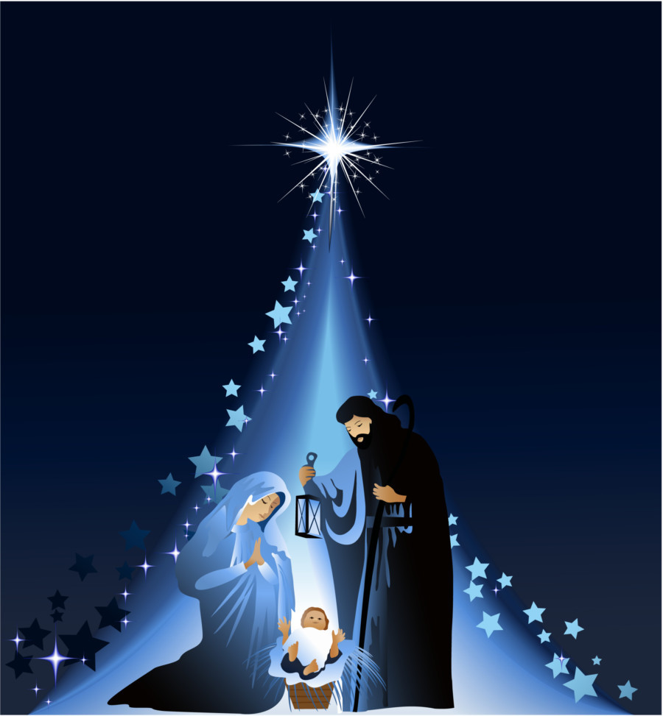
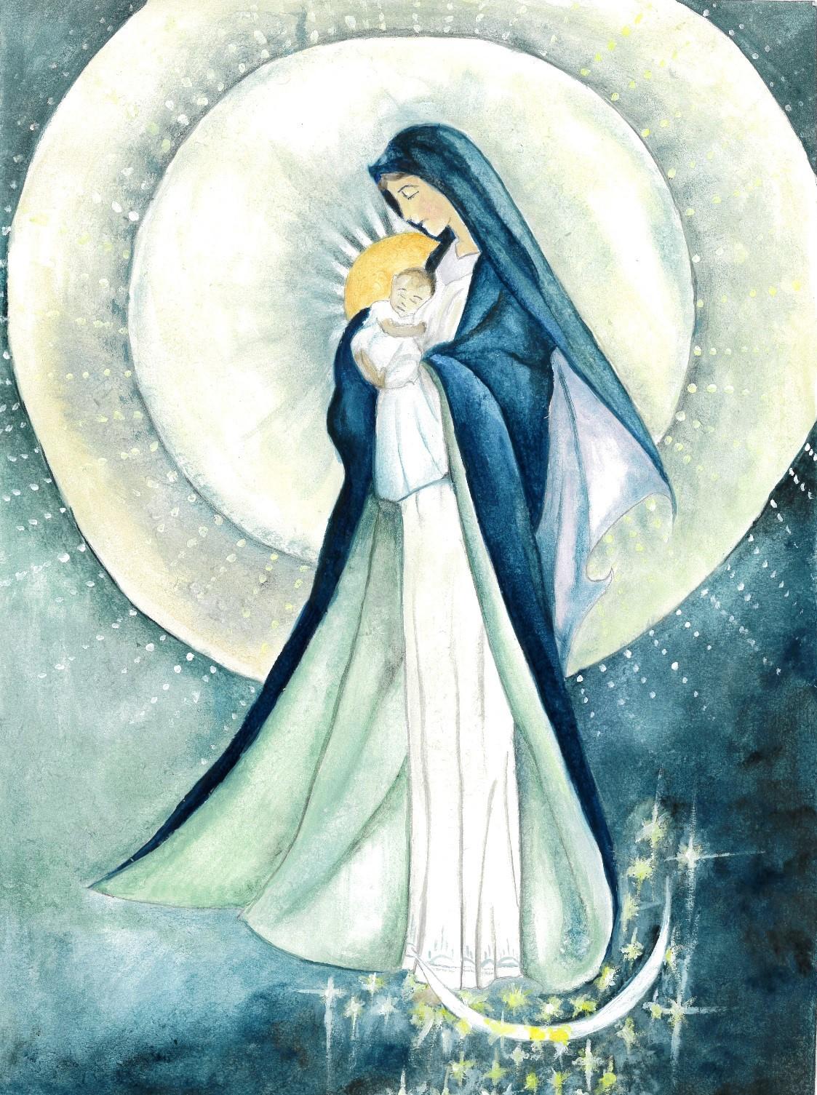
Christmas Message 2021 from Fr Graziano

Dear Parishioners, I recently remembered a very sweet Italian poem I read years ago. I did some research and I found it on the internet but sadly I can't say the name of the author. For sure, after reading the poem, you will all agree that the person who composed it shares a gentle soul and a big heart. This year I would like to borrow this poem, to express my sentiments and my best wishes for Christmas. I have included the original version in case you would like to learn a bit of Italian. Maybe next time you could greet me by saying “Buon Natale” (Merry Christmas).

Il Natale è amicizia
Christmas is friendship

Se hai amici, cercali, il Natale è incontrarsi.
If you have friends, find them, Christmas is getting together.

Se hai debiti, pagali, il Natale è giustizia.
If you have debts, pay them, Christmas is doing the right thing.

Se conosci poveri, aiutali, il Natale è dono.
If you know poor people, help them, Christmas is giving

Se hai superbia, interrarla, il Natale è umilta'.
If you are arrogant, tone it down, Christmas is about humility.

Se sei nelle tenebre, cerca la Luce, il Natale è luce.
If you are in darkness, look for the light, Christmas is light.

Se sei nell'errore, rifletti, il Natale è verita'.
If you are wrong, reflect upon it, Christmas is truth.

Se sei triste, rallegrati, il Natale è gioia.
If you are sad, lighten up, Christmas is joy.

Se hai odio, dimenticalo perchè, il Natale è amore!
If you have hate, forget it because, Christmas is love!
COVID-19 MEASURES – PLEASE NOTE THAT MOST MEASURES REMAIN IN PLACE
- Wearing of face coverings is now again required, unless you are unable to for medical reasons.
- Using the “ONE WAY SYSTEM” entering the main front door and leaving by the side door of the church
- Congregational singing is now allowed.
- Sign of the peace is omitted
- Children are not allowed to wander around the church for their own protection and other people’s safety
- Votive candles are available
- Following the Social Distancing rule of 1 metre or more, we can now accomodate 86 people. (The seating areas have green signage).
- We have reintroduced bidding prayers
- The Offertory Procession will be reintroduced when music is available, with those involved sanitising their hands immediately before they touch the sacred vessel or other gifts
- The Holy Communion will continue to be under one kind and the Minister will continue to wear a face covering and it is permitted to announce “the Body of Christ” for each communicant. Communion is recommended to be distributed in the hands, but if people wish to receive on the tongue, then they should wait until the end of the communion line and receive then. Communion on the tongue exposes the ministers’ hands to their aerosol and inccreases the possibility of viral infections. He will have to sanitize his hands again immediately after.

CHRISTMAS EVE 10pm MASS

The Nativity of the Lord (Vigil) – Year C

First Reading Isaiah 62:1-5
About Zion I will not be silent, about Jerusalem I will not grow weary, until her integrity shines out like the dawn and her salvation flames like a torch. The nations then will see your integrity, all the kings your glory, and you will be called by a new name, one which the mouth of the Lord will confer. You are to be a crown of splendour in the hand of the Lord, a princely diadem in the hand of your God; no longer are you to be named Forsaken’ nor your land ‘Abandoned’ but you shall be called ‘My Delight’ and your land ‘The Wedded’; for the Lord takes delight in you and your land will have its wedding.
Like a young man marrying a virgin, so will the one who built you wed you, and as the bridegroom rejoices in his bride, so will your God rejoice in you. The word of the Lord

Psalm: 88:4-5,16-17,27,29, R.Cf.v.2

Response: I will sing forever of your love, O Lord.
‘I have made a covenant with my chosen one;
I have sworn to David my servant:
I will establish your dynasty for ever
and set up your throne through the ages. R#

Happy the people who acclaim such a king,
who walk, O lord, in the light of your face,
who find their joy every day in your name,
who make your justice the source of their bliss. R#

‘He will say to me: “You are my father,
my God, the rock who saves me.”
I will keep my love for him always;
for him my covenant shall endure. R#

Second Reading Acts 13:16-17,22-25.
When Paul reached Antioch in Pisidia, he stood up in the synagogue, held up a hand for silence and began to speak: ‘Men of Israel, and fearers of God, listen! The God of our nation Israel chose our ancestors, and made our people great when they were living as foreigners in Egypt; then by divine power he led them out. ‘Then he made David their king, of whom he approved in these words, “I have selected David son of Jesse, a man after my own heart, who will carry out my whole purpose.” To keep his promise, God has raised up for Israel one of David’s descendants, Jesus, as Saviour, whose coming was heralded by John when he proclaimed a baptism of repentance for the whole people of Israel. Before John ended his career he said, “I am not the one you imagine me to be; that one is coming after me and I am not fit to undo his sandal.”’
The word of the Lord

Gospel Acclamation:

Alleluia, alleluia!
Tomorrow there will be an end to the sin of the world
and the saviour of the world will be our king.
Alleluia!
Priest: The Lord be with you. All: And with your Spirit.

Priest: A reading from the Holy Gospel according to … All: Glory to you, O Lord.

Gospel Matthew 1: 18-25
This is how Jesus Christ came to be born. His mother Mary was betrothed to Joseph; but before they came to live together she was found to be with child through the Holy Spirit. Her husband Joseph; being a man of honour and wanting to spare her publicity, decided to divorce her informally. He had made up his mind to do this when the angel of the Lord appeared to him in a dream and said, ‘Joseph son of David, do not be afraid to take Mary home as your wife, because she has conceived what is in her by the Holy Spirit. She will give birth to a son and you must name him Jesus, because he is the one who is to save his people from their sins.’ Now all this took place to fulfil the words spoken by the Lord through the prophet: The virgin will conceive and give birth to a son and they will call him Emmanuel, a name which means ‘God-is-with-us.’ When Joseph woke up he did what the angel of the Lord had told him to do: he took his wife to his home and, though he had not had intercourse with her, she gave birth to a son; and he named him Jesus.

Priest: The Gospel of the Lord.
All: Praise to you, Lord Jesus Christ.

CHRISTMAS DAY 10am

The Nativity of the Lord (Day) – Year C

First Reading Isaiah 52:7-10
How beautiful on the mountains, are the feet of one who brings good news, who heralds peace, brings happiness, proclaims salvation, and tells Zion, ‘Your God is king!’ Listen! Your watchmen raise their voices they shout for joy together, for they see the Lord face to face,
as he returns to Zion. Break into shouts of joy together, you ruins of Jerusalem; for the Lord is consoling his people, redeeming Jerusalem.
The Lord bares his holy arm in the sight of all the nations, and all the ends of the earth shall see the salvation of our God. The word of the Lord

Psalm: 88:4-5,16-17,27,29, R.Cf.v.2
Response: All the ends of the earth have seen the salvation of our God.
Sing a new song to the lord
for he has worked wonders.
His right hand and his holy arm
have brought salvation. R

The Lord has made known his salvation;
has shown his justice to the nations.
He has remembered hi truth and love
for the house of Israel. R

All the ends of the earth have seen
the salvation of our God.
Shout to the Lord all the earth,
ring out your joy. R

Sing psalms to the Lord with the harp,
with the sound of music.
With trumpets and the sound of the horn
acclaim the King, the Lord. R

Second Reading Hebrews 1:1-6
At various times in the past and in various different ways, God spoke to our ancestors through the prophets; but in our own time, the last days, he has spoken to us through his Son, the Son that he has appointed to inherit everything and through whom he made everything there is. He is the radiant light of God’s glory and the perfect copy of his nature, sustaining the universe by his powerful command; and now that he has destroyed the defilement of sin, he has gone to take his place in heaven at the right hand of divine Majesty. So he is now as far above the angels as the title which he has inherited is higher than their own name God has never said to any angel: You are my Son, today I have become your father; or: I will be a father to him and he a son to me. Again, when he brings the First-Born into the world, he says: Let all the angels of God worship him. The word of the Lord

Alleluia, alleluia!
A hallowed day has dawned upon us.
Come, you nations, worship the Lord,
for today a great light has shone down upon the earth. Alleluia!

Priest: The Lord be with you. All: And with your Spirit.

Priest: A reading from the Holy Gospel according to … All: Glory to you, O Lord.

Gospel John 1:1-18
In the beginning was the Word: and the Word was with God and the Word was God.
He was with God in the beginning. Through him all things came to be, not one thing had its being but through him. All that came to be had life in him and that life was the light of men,
a light that shines in the dark, a light that darkness could not overpower.]
A man came, sent by God. His name was John. He came as a witness, as a witness to speak for the light, so that everyone might believe through him. He was not the light, only a witness to speak for the light.[The Word was the true light that enlightens all men; and he was coming into the world.
He was in the world that had its being through him, and the world did not know him. He came to his own domain and his own people did not accept him. But to all who did accept him he gave power to become children of God, to all who believe in the name of him who was born not out of human stock or urge of the flesh or will of man but of God himself.
The Word was made flesh, he lived among us, and we saw his glory, the glory that is his as the only Son of the Father, full of grace and truth.]
John appears as his witness. He proclaims: ‘This is the one of whom I said: He who comes after me ranks before me because he existed before me.’ Indeed, from his fullness we have, all of us, received – yes, grace in return for grace, since, though the Law was given through Moses, grace and truth have come through Jesus Christ. No one has ever seen God; it is the only Son, who is nearest to the Father’s heart, who has made him known.

Priest: The Gospel of the Lord. All: Praise to you, Lord Jesus Christ.

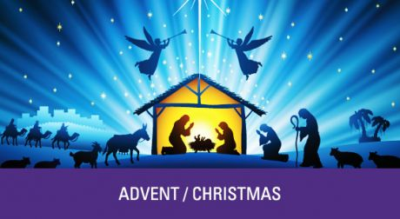

MERRY CHRISTMAS 2021 TO YOU ALL
FROM FR GRAZIANO AND THE PARISH TEAM

