SACRED HEART OF JESUS - CHRISTMAS NEWSLETTER
Parish Priest – Fr Graziano de Palma
Contact Details: Presbytery Phone – 01795 472619 – Office Phone – 01795 555708
Office Hours: Mon, Weds & Fri 9am -1pm sittingbourne@rcaos.org.uk

For your personal use, please take this newsletter away with you
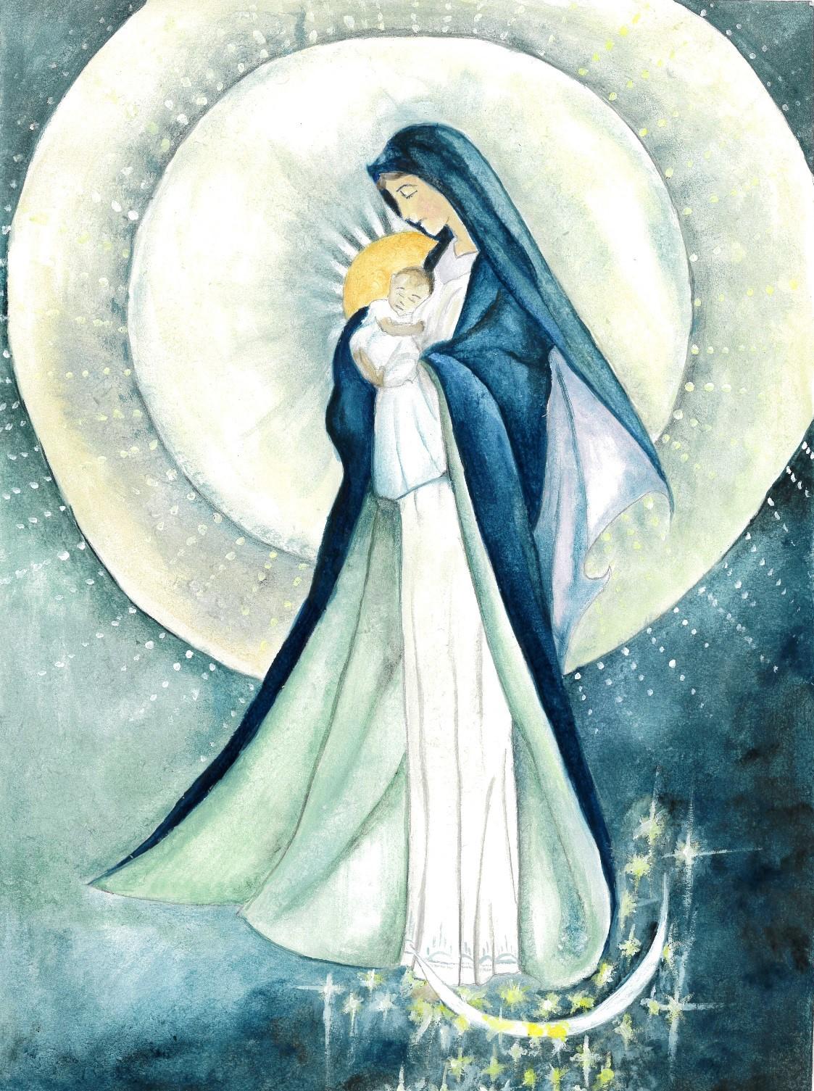
Christmas Message 2021 from Fr Graziano

Dear Parishioners, I recently remembered a very sweet Italian poem I read years ago. I did some research and I found it on the internet but sadly I can't say the name of the author. For sure, after reading the poem, you will all agree that the person who composed it shares a gentle soul and a big heart. This year I would like to borrow this poem, to express my sentiments and my best wishes for Christmas. I have included the original version in case you would like to learn a bit of Italian. Maybe next time you could greet me by saying “Buon Natale” (Merry Christmas).

Il Natale è amicizia
Christmas is friendship

Se hai amici, cercali, il Natale è incontrarsi.
If you have friends, find them, Christmas is getting together.

Se hai debiti, pagali, il Natale è giustizia.
If you have debts, pay them, Christmas is doing the right thing.

Se conosci poveri, aiutali, il Natale è dono.
If you know poor people, help them, Christmas is giving

Se hai superbia, interrarla, il Natale è umilta'.
If you are arrogant, tone it down, Christmas is about humility.

Se sei nelle tenebre, cerca la Luce, il Natale è luce.
If you are in darkness, look for the light, Christmas is light.

Se sei nell'errore, rifletti, il Natale è verita'.
If you are wrong, reflect upon it, Christmas is truth.

Se sei triste, rallegrati, il Natale è gioia.
If you are sad, lighten up, Christmas is joy.

Se hai odio, dimenticalo perchè, il Natale è amore!
If you have hate, forget it because, Christmas is love!
Saturday CHRISTMAS DAY - THE NATIVITY OF THE LORD
25th December 10am Angelo de Palma R.I.P.
Sunday BOXING DAY - THE HOLY FAMILY OF JESUS, MARY & JOSEPH
26th December 9.30am Valerie Jennings R.I.P.
11am People of the Parish.
Monday ST JOHN, APOSTLE
27th December NO MASS
Tuesday 28th December 6pm NO MASS
Wednesday ST THOMAS OF CANTERBURY
29th December 10am
12noon Requiem Mass – Mrs Margaret Spicer
Thursday 30th December 10am John, Daisy Egan R.I.P.
Friday 31st December 10am Mary Rice R.I.P.
Saturday NEW YEAR’S DAY
1st January 4.30pm Confession
5pm People of the Parish.
Sunday
2nd January 9.30am tbc
11am tbc

COVID-19 MEASURES – PLEASE NOTE THAT MOST MEASURES REMAIN IN PLACE
- Wearing of face coverings is now again required, unless you are unable to for medical reasons.
- Using the “ONE WAY SYSTEM” entering the main front door and leaving by the side door of the church
- Congregational singing is now allowed.
- Sign of the peace is omitted
- Children are not allowed to wander around the church for their own protection and other people’s safety
- Votive candles are available
- Following the Social Distancing rule of 1 metre or more, we can now accomodate 86 people. (The seating areas have green signage).
- We have reintroduced bidding prayers
- The Offertory Procession will be reintroduced when music is available, with those involved sanitising their hands immediately before they touch the sacred vessel or other gifts
- The Holy Communion will continue to be under one kind and the Minister will continue to wear a face covering and it is permitted to announce “the Body of Christ” for each communicant. Communion is recommended to be distributed in the hands, but if people wish to receive on the tongue, then they should wait until the end of the communion line and receive then. Communion on the tongue exposes the ministers’ hands to their aerosol and inccreases the possibility of viral infections. He will have to sanitize his hands again immediately after.

The Holy Family of Jesus, Mary, and Joseph – Year C

Entrance Antiphon.

The Shepherds went in haste and found Mary and Joseph and the Infant
lying in a manger.

In the name of the Father, and of the Son, and of the Holy Spirit. Amen.

C. The Lord be with you
All. And with your Spirit

All: I confess to almighty God
And you my brothers and sisters,
That I have greatly sinned,
In my thoughts and in my words,
In what I have done and in what I have failed to do,
through my fault, through my fault,
through my most grievous fault;
therefore, I ask blessed Mary ever-virgin,
all the Angels and Saints,
and you my brothers and sisters,
to pray for me to the Lord our God.

C: Lord, have mercy. All: Lord, have mercy.
C: Christ have mercy. All: Christ have mercy.
C: Lord, have mercy. All: Lord, have mercy.

All: Glory to God in the highest
And on earth peace to people of goodwill.
We praise you,
We bless you,
We adore you; we glorify you; we give you thanks for your great glory,
Lord God, heavenly King,
O God, almighty Father.
Lord Jesus Christ, Only Begotten Son,
Lord God, Lamb of God, Son of the father,
You take away the sins of the world, have mercy on us;
You take away the sins of the world, receive our prayer;
You are seated at the right hand of the Father,
Have mercy on us.
For you alone are the Holy One,
You alone are the Lord,
You alone are the Most High
Jesus Christ,
With the Holy Spirit,
In the glory of the Father.
Amen

C: Let us pray.

First Reading 1 Samuel 1:20-22,24-28
Hannah conceived and gave birth to a son, and called him Samuel ‘since’ she said ‘I asked the Lord for him’ When a year had gone by, the husband Elkanah went up again with all his family to offer the annual sacrifice to the Lord and to fulfil his vow. Hannah, however, did not go up, having said to her husband, ‘Not before the child is weaned. Then I will bring him and present him before the Lord and he shall stay there forever. ’When she had weaned him, she took him up with her together with a three-year-old bull, an ephah of flour and a skin of wine, and she brought him to the temple of the Lord at Shiloh; and the child was with them. They slaughtered the bull and the child’s mother came to Eli. She said, ‘If you please, my lord. As you live, my lord, I am the woman who stood here beside you, praying to the Lord. This is the child I prayed for, and the Lord granted me what I asked him. Now I make him over to the Lord for the whole of his life. He is made over to the Lord.’
The word of the Lord.

Psalm: 83:2-3,5-6,9-10. R.v.5

Response: They are happy who dwell in your house, O Lord.
How lovely is your dwelling place,
Lord, God of Hosts
My souls is longing and yearning,
is yearning for the courts of the Lord.
My heart and my souls ring out their joy
to God, the living God. R#

They are happy who dwell in your house,
for ever singing your praise.
They are happy, whose strength is in you;
they walk with ever growing strength. R#

O Lord, God of hosts, hear my prayer,
give ear, O God of Jacob.
Turn your eyes, O God, our shield,
look on the face of your anointed. R#

Second Reading 1John 3:1-2,21-24
Think of the love that the Father has lavished on us,
by letting us be called God’s children;
and that is what we are.
Because the world refused to acknowledge him,
therefore it does not acknowledge us.
My dear people, we are already the children of God
but what we are to be in the future has not yet been revealed;
all we know is, that when it is revealed
we shall be like him
because we shall see him as he really is.
My dear people,
if we cannot be condemned by our own conscience,
we need not be afraid in God’s presence,
and whatever we ask him,
we shall receive,
because we keep his commandments
and live the kind of life that he wants.
His commandments are these:
that we believe in the name of his Son Jesus Christ
and that we love one another
as he told us to.
Whoever keeps his commandments
lives in God and God lives in him.
We know that he lives in us
by the Spirit that he has given us.
The word of the Lord.

Alleluia, alleluia!
Open our heart, O Lord,
to accept the words of your Son.
Alleluia!

Priest: The Lord be with you All: And with your Spirit.

Priest: A reading from the Holy Gospel according to …. All: Glory to you, O Lord.

Gospel Luke 2:41-52
Every year the parents of Jesus used to go to Jerusalem for the feast of the Passover. When he was twelve years old, they went up for the feast as usual. When they were on their way home after the feast, the boy Jesus stayed behind in Jerusalem without his parents knowing it. They assumed he was with the caravan, and it was only after a day’s journey that they went to look for him among their relations and acquaintances. When they failed to find him they went back to Jerusalem looking for him everywhere. Three days later, they found him in the Temple, sitting among the doctors, listening to them, and asking them questions; and all those who heard him were astounded at his intelligence and his replies. They were overcome when they saw him, and his mother said to him, ‘My child, why have, you done this to us? See how worried your father and I have been, looking for you. ’‘Why were you looking for me?’ he replied. ‘Did you not know that I must be busy with my Father’s affairs?’ But they did not understand what he meant. .He then went down with them and came to Nazareth and lived under their authority. .His mother stored up all these things in her heart. And Jesus increased in wisdom, in stature, and in favour with God and men.

Priest: The Gospel of the Lord All: Praise to you, Lord Jesus Christ.

I believe in one God, the Father almighty, maker of heaven and earth, of all things visible and invisible. I believe in one Lord Jesus Christ, the Only Begotten Son of God, born of the Father before all ages. God from God, Light from Light, true God from true God, begotten, not made, consubstantial with the Father; through him all things were made. For us men and for our salvation he came down from heaven, (all bow) and by the Holy Spirit was incarnate of the Virgin Mary and became man. For our sake he was crucified under Pontius Pilate, he suffered death and was buried, and rose again on the third day in accordance with the Scriptures. He ascended into heaven and is seated at the right hand of the Father. He will come again in glory to judge the living and the dead and his kingdom will have no end. I believe in the Holy Spirit, the Lord, the giver of life, who proceeds from the Father and the Son, who with the Father and the Son is adored and glorified, who has spoken through the prophets. I believe in one, holy, catholic, and apostolic Church I confess one Baptism for the forgiveness of sins and I look forward to the resurrection of the dead and the life of the world to come. Amen.

Liturgy of the Eucharist:

C: Pray, brethren….

All: May the Lord accept the sacrifice at your hands
for the praise and glory of his name
for our good and the good of all his holy Church.

C: The Lord be with you All: and with your Spirit
C: Lift up your hearts. All: We lift them up to the Lord.
C: Let us give thanks to the Lord our God. All: it is right and just.

All: Holy, Holy, Holy, Lord God of hosts
Heaven and earth are full of your glory
Hosanna in the highest.
Blessed is he who comes in the name of the Lord.
Hosanna in the highest.

Lord’s Prayer: Our Father…

C: ……. And the coming of our Saviour, Jesus Christ.

All: For the kingdom the power and the glory are yours now and for ever.

All: Lamb of God, you take away the sins of the world, have mercy on us.
Lamb of God, you take away the sins of the world, have mercy on us.
Lamb of God, you take away the sins of the world, grant us peace.

C: Behold the Lamb of God ……..

All: Lord, I am not worthy
that you should enter under my roof,
but only say the word
and my soul shall be healed.

Communion Antiphon:
Our God has appeared on earth and lived among us. Ba.3:38.
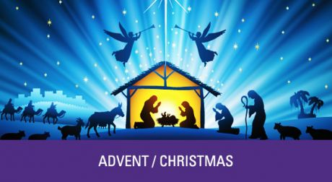
C: Let us Pray……….

C: The Lord be with you
All: And with your Spirit.

C: May Almighty God bless you,
The Father, and the Son, and the Holy Spirit.
All: Amen

Priest: Go in peace, glorifying the Lord by your life.
All: Thanks be to God.

MERRY CHRISTMAS 2021 TO YOU ALL
FROM FR GRAZIANO AND THE PARISH TEAM

